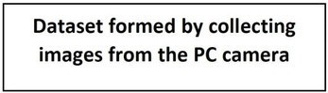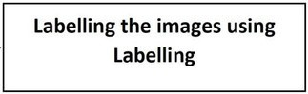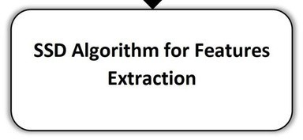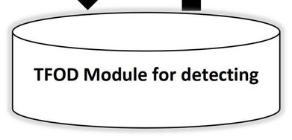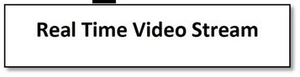

**Solution Architecture**

Team ID

PNT2022TMID18766

Project Name

Real-Time

Communication

System

Powered

by

AI

for

Specially

Abled